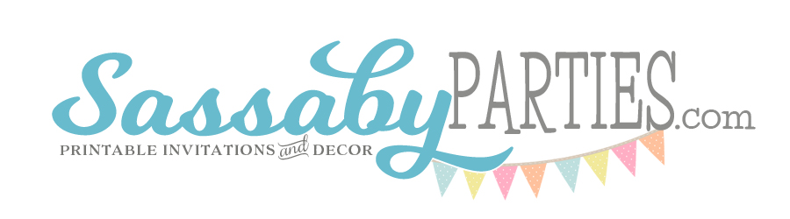
Sassaby DIY Printable Parties
Queensland, Australia
www.sassabyparties.com

Date: {enter date here}

To Whom It May Concern:

I, Amy Sampson, am the owner, designer and copyright holder of all digital printable designs created and distributed by Sassaby - DIY Printable Parties located at www.sassabyparties.com and www.sassaby.etsy.com, at the office of Sassaby P/L Suite 1, 4 Stoneybrook Place, Peregian Springs Qld, Australia 4573.

I hereby grant {enter your name here} my permission to make unlimited printed copies, for their Personal Use, using this/these digital file(s) as provided by me through a digital online sale, and distributed by me via email.

If you should have any questions regarding the authenticity of this document or the terms herewith, please contact me at:

Phone: +61 4 3571 4407 (Australian Mobile Phone) -or-

Email: amy@sassaby.com.au

Sincerely,
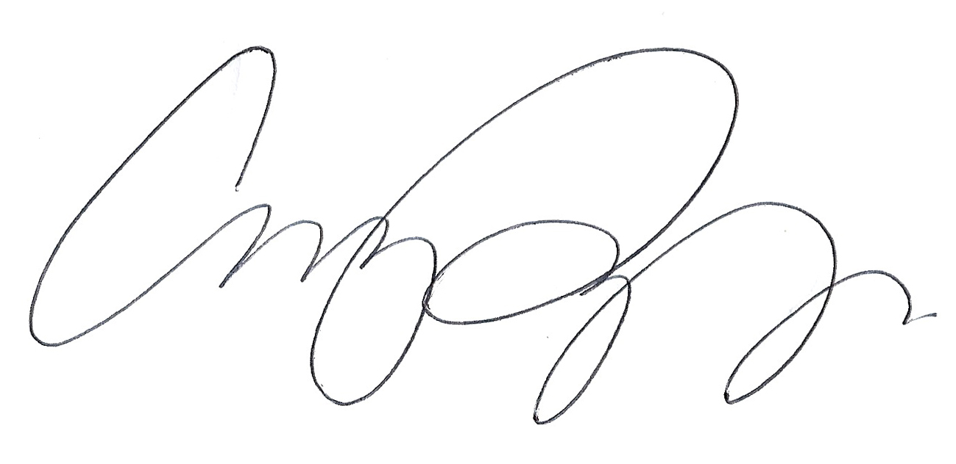

Amy Sampson
Designer and Copyright Holder

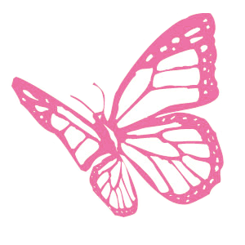

Sassaby DIY Printable Parties
www.sassaby.com.au ~ www.sassaby.etsy.com
sales@sassaby.com.au

Please note: All Designs are Copyright © Sassaby 2011. All Rights Reserved.

You have been granted the printing rights for Personal Use Only of these products.
You MAY NOT share, forward, sell, or re-distribute any Sassaby Digital Product.

